The Philippines’ Rapid Economic Growth and Its Potential Threats

Composed by: Uyanga Enkhriimaa and Yoon Ah Kang

I. Introduction
Our interest is in the rapidly growing Southeast Asian market. Recently, the market has been growing in an unexpected rate and is becoming very compelling for investors. Among many Southeast Asian countries, the Philippines is known to be one of the leading economic markets in the region. Thus, we tried to observe the Philippines’ economic growth and its obstacles. This paper aims to 1) examine the background and driving forces behind the Philippines’ economic growth, 2) identify the inherent risk factors in the Philippines’ economic situation, and 3) ponder upon the country’s future development plans and consider whether the Philippines can play a leading role in the Southeast Asian economy in the future.
To write this paper, we utilized multiple news articles from various English and Korean sources. While our findings reflect the overall situation of the Philippines’ economy, we cannot state for sure that these findings will be consistent in the upcoming months. Hence, our findings are susceptible to changes due to the rapidly changing economic and political situation in the Philippines requiring consistent updates after its submission.

II. The Philippines’ Economic Growth
The Philippines remains as one of the best performing economies in Southeast Asia. As observed in figure 1, they hit a GDP growth rate of 6.8% in the first quarter of 2018 and has been recording a GDP growth rate of 6.5% and higher for the past 10 consecutive quarters.
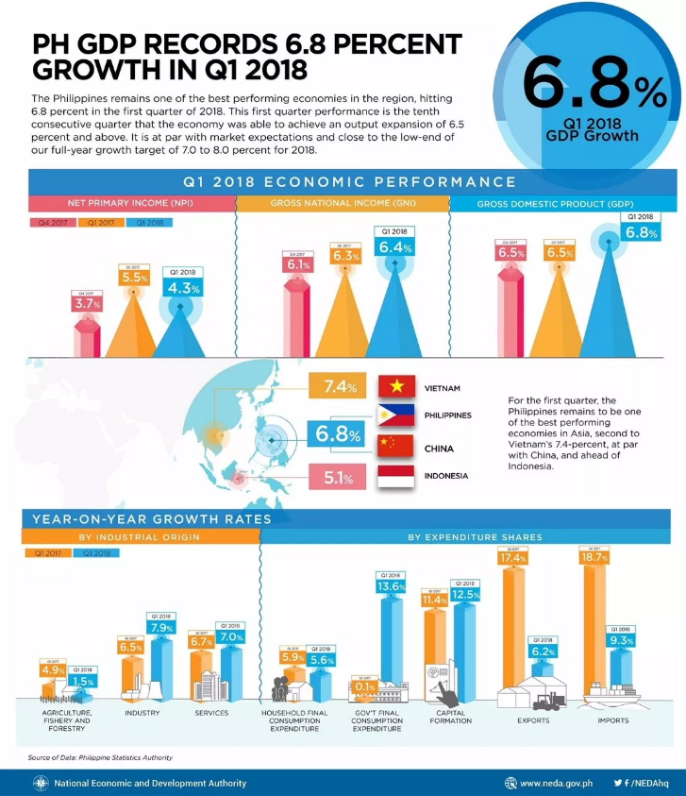
Figure 1. The Philippines’ GDP Growth Rate in Q1 2018
(Source: http://customstrade.asia/2018/05/10/ph-economy-registers-6-8-growth-in-q1/)

The Asian Development Bank (hereafter ADB) director for the Philippines, Kelly Bird, briefed that the strong growth of the Philippines’ economy was driven by high domestic demand and that the country is in its golden age of economic growth. As its economy has been growing at a consistent pace for the past several years, this growth is expected to be sustained until 2019.
The president of the Philippines, Rodrigo Duterte (hereafter Duterte) claimed during his speech at the 51st Asian Development Bank meeting that the Philippines’ economy will grow faster during his administration. While the Philippine government is targeting a 7-8% annual GDP growth rate, Duterte cited transportation, infrastructure, protection of civil order, and the fight against corruption and drugs as the priorities for his government to sustain and reach the promised GDP growth rate of 7-8%. He also believes that shifting the focus in foreign policies from the United States to other countries will help further the development of Philippines’ economy. “We will exert all efforts to build a truly inclusive economy that benefits our people for the next few years. [It] will be an interesting time for the region.” In accordance with his new foreign policy target, around $185.7 million worth of investment agreements were signed between the Filipino and Singaporean companies on the sideline of the Association of Southeast Asian Nations (ASEAN) Summit in Singapore last April 2018 (figure 2).

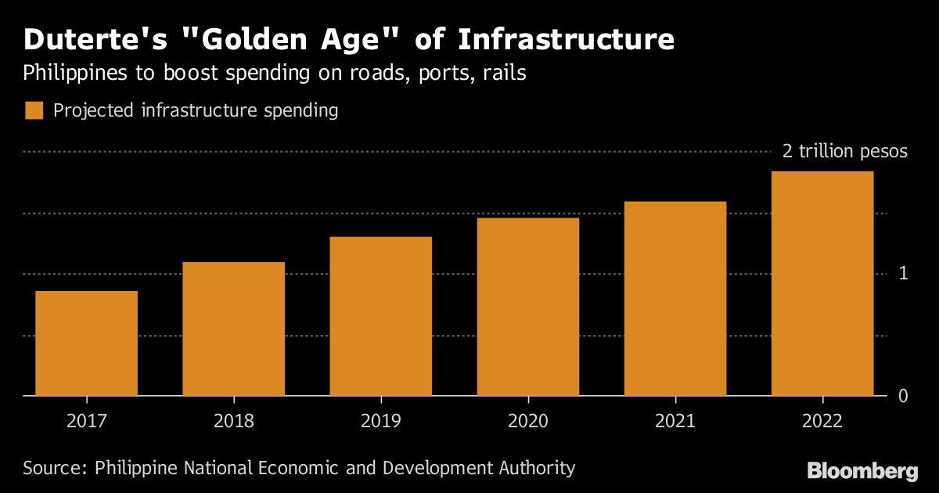
Figure 2. The Projected Infrastructure Spending in the Philippines
(Source: https://www.bloomberg.com/news/articles/2018-01-23/duterte-s-180-billion-building-boom-may-be-expats-ticket-home)

The main economic sectors that have shown rapid growth in 2017 were the following: industry (recorded a growth of 7.2%), services (a growth of 6.8%), and the agriculture and fishing industry recovered its decline in the previous year and demonstrated a growth of 4% in 2017. However, it is noted that its performance declined again in the first quarter of 2018 because of the TRAIN Law. In total, the service industry accounted for 59.8% of the Philippines’ GDP, followed by the industrial sector of 30%, and the agriculture and fishing industry with 9.4%. Hence, it is expected that the service sector will be the leading industry in the Philippines. Moreover, the Manila-based multilateral financing bank ADB also states that business optimism is high, “along with domestic demand, the government’s infrastructure investments will fuel the country’s growth in the next few years, supported by a sound economic policy setting.”

GDP Composition by Sector | Agriculture and Fishery: 9.4%  Industry: 30.8%  Services: 59.8%
Industries | Semiconductors and electronics assembly, food and beverage manufacturing, construction, electric/gas/water supply, chemical products, radio/television/communications equipment and apparatus, petroleum and fuel, textile and garments, non-metallic minerals, basic metal industries, transport equipment
Agricultural Products | Rice, fish, livestock, poultry, bananas, coconut/copra, corn, sugarcane, mangoes, pineapple, cassava
Table 1. Main Economic Sectors of the Philippines (2017 est.)
III. The Inherent Risk Factors
- High Inflation Rate
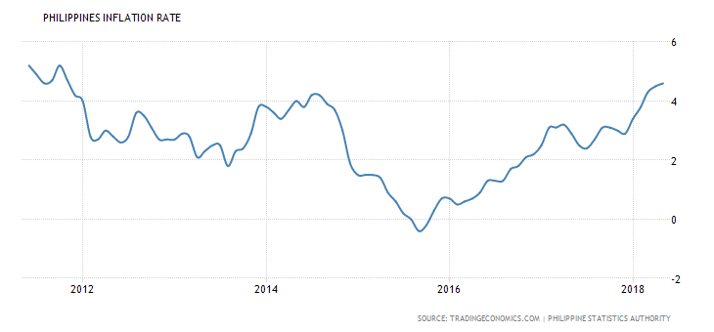
Figure 3. Philippines’ Inflation Rate
(Source: https://tradingeconomics.com/philippines/inflation-cpi?user=analyst38705)

Figure 3, based on a report from the Philippine Statistics Authority, illustrates that the Philippines’ year-on-year headline inflation rate has hit a year high in April 2018. Inflation peaked up by 4.5% in April and the last time the country’s inflation rate rose this high was in November 2011 by 4.8%. Since the headline inflation rate reflects the change in prices of basic goods, it directly affects people’s economic sentiment.
Costs rose at a faster rate last April for alcoholic beverages and tobacco (20% from 18.6%); clothing and footwear (2.2% from 2%); housing, water, electricity, gas and other fuels (3% from 2.9%); furnishing, household equipment, and routine maintenance (2.8% from 2.7%); heath (2.8% from 2.4%); transport (4.9% from 4.6%); recreation and culture (1.5% from 1.4%); and restaurant and miscellaneous goods and services (3.4% from 3%). Moreover, prices of heavily-weighted food and non-alcoholic beverages increased by 5.9%, similar to the previous month’s figure, whereas the inflation rate was steady for communication (0.3%) and education (1.8%).
The Socioeconomic Planning Secretary, Ernesto Pernia said in a press conference last March that “inflation is the spoiler.” He argued that if it was not for the increase in inflation rate from the first quarter of 2017 to the first quarter of 2018, the real GDP growth rate could have been well within the growth range target of 7-8%. Consequently, the central bank governor Nestor Espenilla stated that the inflation rate was being driven by supply-side factors which include food prices, rise in oil prices, and the impacts from tax reform. He claimed that the government is too focused on the ‘Build, Build, Build Infrastructure Program’ and is spending too much fiscally. For instance, the Tax Reform for Acceleration and Inclusion (TRAIN) Law which took effect last year is one of the government’s main programs.
The TRAIN Law was signed by Duterte last December 2017 and is one of the five tax packages under the administration’s tax reform plan. The new tax reform plan is expected to generate money to fund the administration’s infrastructure projects while reducing income tax for the individual income taxpayers. Experts think that inflation was mainly due to the impact of the new tax reform law. The TRAIN Law exempts those earning ₱250,000 annually or around ₱22,000 per month from income tax but imposes higher tax rates on fuel, sin products, and sugary drinks. Hence, beverage products that utilizes sweeteners and syrup, tobacco, and cosmetic surgeries are all imposed increased tax rates which lead to headline inflation.
On the contrary, some sellers are taking advantage of the TRAIN Law by prematurely increasing their selling prices despite the fact that no additional input costs were brought to their production and services. Meanwhile, investors’ concerns on inflation need to be addressed in order to prevent the negative effects on the Philippines’ foreign exchange market. It has to be noted that the Philippine Peso depreciated to 4.6% against the US dollar this year and this has been its lowest rate in the last 12 years. While emerging markets such as the Argentine Peso, Turkish Lira, Brazilian Real, Russian Ruble, and Indian Rupee have all been hit hard, the Philippine Peso has been hit by worries that fiscal deficit will continue due to an increase in trade deficit.
Although the central bank raised the interest rates to address inflation, it was not enough to slow down the ongoing weakening bond market. Additionally, the Bangko Sentral ng Pilipinas (hereafter BSP) said that there is no cause for the alarm. It claimed that the rise in consumer prices is temporary as the effects of the tax reform will kick in and prices will normalize by 2019. As such, the central bank set an inflation target range of 2-4% while the country tries to manage its inflation rate for the rest of 2018. Amidst higher commodity prices, the bank expects the country to continue its steady growth.

- High Dependency on the Overseas Workers
The Filipino diaspora is perhaps the largest in the world. In 2013, the Commission on Filipinos Overseas (CFO) estimated that approximately 10.2 million Filipinos lived or worked abroad. According to the World Bank’s latest estimates, the Philippines was poised to be the third biggest remittance-receiving country in 2017 with a total of $32.8 billion after India’s $65.4 billion and China’s $62.9 billion. Moreover, the BSP reported that the remittances rose by 7.1% to $2.74 billion last December 2017. As such, last December’s remittance inflow was the largest amount on record and was buoyed by cash remittances from the United States, the United Arab Emirates (UAE), and Singapore.
Remittances are the country’s largest source of foreign exchange, protecting the domestic economy from external shocks by ensuring a steady supply of dollars into the financial market. The personal remittances of OFWs (Overseas Filipino Workers) last year accounted for 10% of its GDP. These cash transfers are now a major driver for domestic consumption, hence contributing to economic growth. However, Filipino foreign workers’ cash remittances on March 2018 was $2.360 billion, having decreased 9.8% from a year earlier. While this was the largest decrease in the past 15 years, this was because the Philippine government stopped sending new workers to Kuwait in February. The government suspended the dispatch of new workers to the country when a Lebanese-Syrian couple living in Kuwait killed a Filipina housekeeper and hid her in a refrigerator for one year. The Philippines had implemented a rescue operation (rescue of the desert) by using vehicles with the embassy staff in Kuwait. While the embassy helped escape 26 housekeepers who were abused by their employers, this resulted to a harsh diplomatic conflict between the two countries. The conflicts have been resolved recently according to a realistic consideration that both countries would suffer immensely if the Philippines’ suspension of dispatched workers is prolonged. With the Kuwaiti government promising the workers’ welfare, the ban was lifted. However, some time still needs to be given in order to recover the absent remittances.
Due to the high dependency on overseas workers by the Philippines’ economy, it may be vulnerable to changes in the political or economic situations. When there is a major political conflict similar to what happened between Kuwait, or a change of foreign immigration policy happens, it will considerably affect the country’s economy.

- Political Instability
Diplomatic clashes between the Philippines and Europe have been rapidly intensified with the Duterte government detaining and expelling EU senior officials earlier this month. Giacomo Filibeck, the deputy secretary of the European Socialist Party and who has been criticizing the violence and supreme legal murder in the “war on drugs” was detained as soon as he arrived at the Cebu Airport in the Philippines last May. While the outspoken Philippine leader is known for defying international pressure and his diatribe against critics, EU’s diplomatic criticism could have a negative impact on the Philippines’ economy.
The European Parliament has announced to take procedural steps to temporarily withdraw preferential trade agreements with the Philippines due to human rights violations. Under the General Preferential Tariff Plus (GSP+), the Philippines exports almost all products to Europe duty-free. The Philippines exports to the EU reached $10 billion last year, making it one of the country’s largest exporters. While the EU in the Philippines is a major source of investment and development assistance, the Philippine-EU Free Trade Agreement (FTA) negotiations were virtually halted by pressure from the European Parliament.
Political instability due to corruption is also an obstacle for solid economic development. Filipino officials were frequently accused of corruption due to their low salaries. While Duterte has made a major commitment during his presidential election in 2016 and the Philippine government decided to take action to raise salary levels, corruption practices were not eradicated despite these efforts.

IV. Future Development Plans and Prospects
- Deepening the Research and Development (R&D) Talent Pool
The Balik Scientist Act approved by the Senate in March 2017 is expected to be ratified by Duterte and come into force by the end of the first half of 2018. The act aims to incentivize scientists and researchers based overseas to return home to expand the R&D talent pool. The benefits include tax and duty exemption on imported professional equipment, free medical insurance, support in securing job opportunities for their spouse, schooling allowances for children, and a relocation subsidy.

- Business Process Outsourcing (BPO)
BPO in the Philippines is becoming a key developing industry primarily due to the relatively low cost of living and a workforce composed mainly of young and highly educated Filipinos with good spoken English skills. Moreover, a majority of international research and data companies have placed the Philippines as the number one trending country as the top outsourcing destination. The BPO industry in the Philippines continues to show significant improvements with an annual expansion rate of 20%. The call centers have overtaken India as the leading call center country. By 2020, the Philippines’ BPO industry is projected to reach a total income of 40 billion USD to 55 billion USD.

- Positive Diplomatic Relations with China
During the Boao Forum in China last April, Duterte urged President Xi Jinping to open its doors to Filipino workers and a memorandum of understanding was signed for the employment of bilingual English teachers from the Philippines. Moreover, Filipino workers employed by China include nurses, caregivers, nannies, cooks, and musicians. As a result of this MOU, William J. Lima, a special envoy for China’s economy, anticipated that a total of 0.5 million workers will be deployed to China. Additionally, there is also a small possibility that the illegal Filipinos in China may obtain legal status with the positive diplomatic relations between the two countries.

- Prospects
Despite some obstacles in the Philippines’ economy, the country is still showing strength in the field and continues to develop. While the World Bank expects the country to sustain its growth in the next 2 years, the government is actively seeking opportunities and investments to develop future industries. This continuous effort can help the Philippines to remain as one of the leading countries in the ASEAN region. However, it still needs to keep an eye on its economic and political instability, since they can cause long-term stagnation.

References

English
ABS-CBN News. (2018). World Bank Expects PH Economy to Sustain Growth in Next 2
Years. Retrieved from http://news.abs-cbn.com/video/business/04/13/18/world-bank-expects-ph-economy-to-sustain-growth-in-next-2-years
Alegado, S. (2018). Duterte’s $180 Billion Building Boom May Be Expats’ Ticket Home.
Retrieved from https://www.bloomberg.com/news/articles/2018-01-23/duterte-s-180-billion-building-boom-may-be-expats-ticket-home
ASEAN Briefing. (2017). Business Process Outsourcing in the Philippines. Retrieved from
https://www.aseanbriefing.com/news/2017/04/17/business-process-outsourcing-philippines.html
Asia Customs & Trade. PH Economy Registers 6.8% Growth in Q1. Retrieved from
http://customstrade.asia/2018/05/10/ph-economy-registers-6-8-growth-in-q1/
Asian Development Bank. (2018). Infrastructure Drive, Strong Domestic Demand to Sustain
Philippine Growth – ADB. Retrieved from https://www.adb.org/news/infrastructure-drive-strong-domestic-demand-sustain-philippine-growth-adb
Business World. (2018). ADB Maintains Bullish Outlook for Philippines. Retrieved from
http://bworldonline.com/adb-maintains-bullish-outlook-for-philippines/
CNN Philippines. (2018). Philippine Inflation Rate Hits 3-year High. Retrieved from
http://cnnphilippines.com/news/2018/03/06/Philippine-inflation-rate-hits-3-year-high.html
CNN Philippines Staff. (2018). Duterte’s Singapore Visit Nets P9-B Worth of Investments.
Retrieved from http://cnnphilippines.com/business/2018/04/28/Duterte-signapore-9-billion-investments.html
Cuaresma, B. (2018). OFW Remittances Hit $28.1 Billion in 2017. Retrieved from
https://businessmirror.com.ph/ofw-remittances-hit-28-1-billion-in-2017/
Guzman, C. D. (2017). Lower Income Tax, Higher Taxes on Sugar, Petroleum, Tobacco
Products by 2018. Retrieved from http://cnnphilippines.com/news/2017/12/13/congress-passes-tax-reform.html
Guzman, L. D. (2018). Duterte: Philippine Economy to Grow by 7%. Retrieved from
http://cnnphilippines.com/business/2018/05/05/duterte-asian-development-bank-
gdp.html
Index Mundi. (2018). Philippines Economy Profile 2018. Retrieved from
https://www.indexmundi.com/philippines/economy_profile.html
Ming, C. (2018). Philippine Central Bank is Looking ‘More Closely’ At Possibility Tweaking
Its Monetary Policy. Retrieved from https://www.cnbc.com/2018/05/04/philippine-central-bank-governor-on-inflation-ahead-of-bsp-policy-meeting.html
Philippines Statistics Authority. (2018). Gross Domestic Product of the Philippines
Highlights for 2017. Retrieved from https://psa.gov.ph/regional-accounts/grdp/highlights
Philippines Statistics Authority. (2018). Summary Inflation Report Consumer Price Index
(2012=100): April 2018. Retrieved from https://www.psa.gov.ph/statistics/survey/price/summary-inflation-report-consumer-price-index-2012100-april-2018
Trading Economics. (n.d.). Philippines Inflation Rate. Retrieved from
https://tradingeconomics.com/philippines/inflation-cpi?user=analyst38705
Trading Economics. (n.d.). Philippines Inflation Rate at Over 6-1/2-Year High of 4.5%.
Retrieved from https://tradingeconomics.com/articles/05042018014326.htm

Korean
안승섭. (2018). 중국내 필리핀 인력 ‘20만50만 명’으로 늘어난다.
https://news.naver.com/main/read.nhn?mode=LSD&mid=sec&sid1=102&oid=001&aid=0010077262
윤승조. (2018). 필리핀 중앙은행 “인플레이션 막기 위한 추가 대책 고민.”
http://www.asiatime.co.kr/news/articleView.html?idxno=184023
전다운. (2018). 필리핀 부패근절 위해 경찰·군인 봉급 2배로 인상한다.
http://www.gokorea.kr/news/articleView.html?idxno=35868
최서윤. (2018). EU ‘반항아’ 두테르테에 휘청이는 필리핀의 대유럽 무역.
http://www.asiatoday.co.kr/view.php?key=20180425010014641

Department of Communication, Seoul National University
Department of Sociology, Seoul National University
http://bworldonline.com/adb-maintains-bullish-outlook-for-philippines/
http://cnnphilippines.com/business/2018/05/05/duterte-asian-development-bank-gdp.html
http://cnnphilippines.com/business/2018/04/28/Duterte-signapore-9-billion-investments.html
https://psa.gov.ph/regional-accounts/grdp/highlights
https://www.adb.org/news/infrastructure-drive-strong-domestic-demand-sustain-philippine-growth-adb
https://www.indexmundi.com/philippines/economy_profile.html
https://www.psa.gov.ph/statistics/survey/price/summary-inflation-report-consumer-price-index-2012100-april-2018
https://tradingeconomics.com/articles/05042018014326.htm
http://cnnphilippines.com/news/2018/03/06/Philippine-inflation-rate-hits-3-year-high.html
https://www.cnbc.com/2018/05/04/philippine-central-bank-governor-on-inflation-ahead-of-bsp-policy-meeting.html
http://cnnphilippines.com/news/2017/12/13/congress-passes-tax-reform.html
http://cnnphilippines.com/news/2018/03/06/Philippine-inflation-rate-hits-3-year-high.html
http://www.asiatime.co.kr/news/articleView.html?idxno=184023
http://cnnphilippines.com/news/2018/03/06/Philippine-inflation-rate-hits-3-year-high.html
https://businessmirror.com.ph/ofw-remittances-hit-28-1-billion-in-2017/
Ibid.
http://www.asiatoday.co.kr/view.php?key=20180425010014641
http://www.gokorea.kr/news/articleView.html?idxno=35868
https://www.aseanbriefing.com/news/2017/04/17/business-process-outsourcing-philippines.html
http://news.naver.com/main/read.nhn?mode=LSD&mid=sec&sid1=102&oid=001&aid=0010077262
http://news.abs-cbn.com/video/business/04/13/18/world-bank-expects-ph-economy-to-sustain-growth-in-next-2-years

