The Current Status of Menstrual Hygiene Management (MHM) in
South Asia: A Focus on India

Composed by: Hye Yong Kim

I. Introduction
While numerous developing countries suffer from hygiene-related issues due to the lack of water and/or infrastructure, India like most South Asian countries, suffer from issues that result from low Menstrual Hygiene Management (hereafter MHM). According to UNICEF (2014), MHM is women and adolescent girls use of a clean material to absorb or collect menstrual blood, and being able to change this material in privacy as often as necessary for the duration of the menstrual period (emphasis added). However, awareness of MHM still remains very low among adolescent girls in India despite the efforts of international (IOs) and non-governmental organizations (NGOs).
It is reported that in India, a majority of women use materials that range from old clothes, rags, soil, and even ash for feminine hygiene. While these materials consequently predispose Indian women to reproductive tract infections (RTIs), menstruation-related cultural taboos that encourage silence around the topic lead to limited information on MHM. Moreover, menstruation affects the school attendance of many girls. It is known that they typically miss four to eight days of school per month (figure 1) due to the lack of a disposal system and water supply. As such, many girls are stuck at home when they are menstruating; leading them to get behind in school, especially in complex and abstract subjects where there is a continued building on previous knowledge. In extreme cases, this leads to a permanent drop-out situation from school.

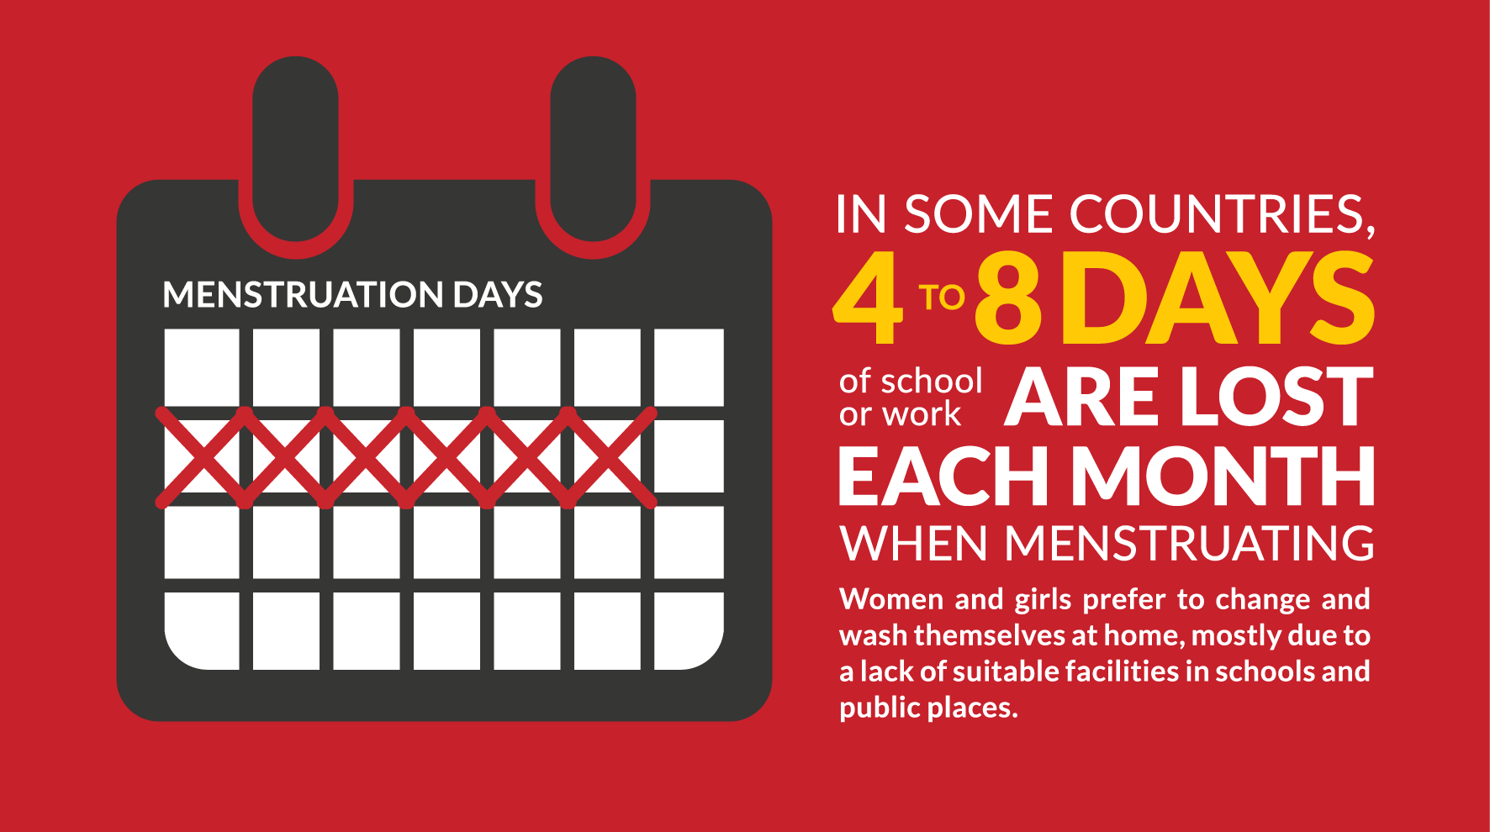
Figure 1. Number of School Days Missed by Girls during Menstruation
Women and girls still face significant barriers to a comfortable and dignified experience when it comes to MHM even if they constitute half of India’s population. As observed in girls’ obstacles in school attendance, menstruation limits the opportunity for women and girls to fully and equally participate in society, undermining their overall social status and self-esteem. Hence, this paper will analyze the current status and limitations of MHM in India and draw possible points of debate.

II. The Status of Menstrual Hygiene Management (MHM) in India
A. Government-level Directives
The three most noticeable government-directed MHM policies were the following: 1) Union Health and Family Welfare Ministry’s (hereafter UHFWM) 2010 scheme, 2) Supreme Court’s 2011 directive, and 3) the Government’s Total Sanitation Campaign (TSC) that was launched in 1999. Observing that MHM was greatly related to the fact that both Above Poverty Line (APL) and Below Poverty Line (BPL) girls were unable to afford commercial sanitary products, the UHFWM approved a scheme on 15 June, 2010 to subsidize sanitary napkins to adolescent girls in the rural areas. Under the scheme, sanitary products were supplied to both the APL and BPL category girls at a nominal cost of INR 01 (KRW 16) per napkin and INR 05 (KRW 80) per pack of six napkins. The central government procured these napkins and supplied them to the states that in return, sent these to the local health functionaries or ASHAs (Accredited Social Health Activists) in the villages for distribution. Moreover, the ASHAs were not only in charge of sanitary napkin distribution but they also facilitated meetings to enhance MHM awareness among Indian girls, as observed in figure 2.

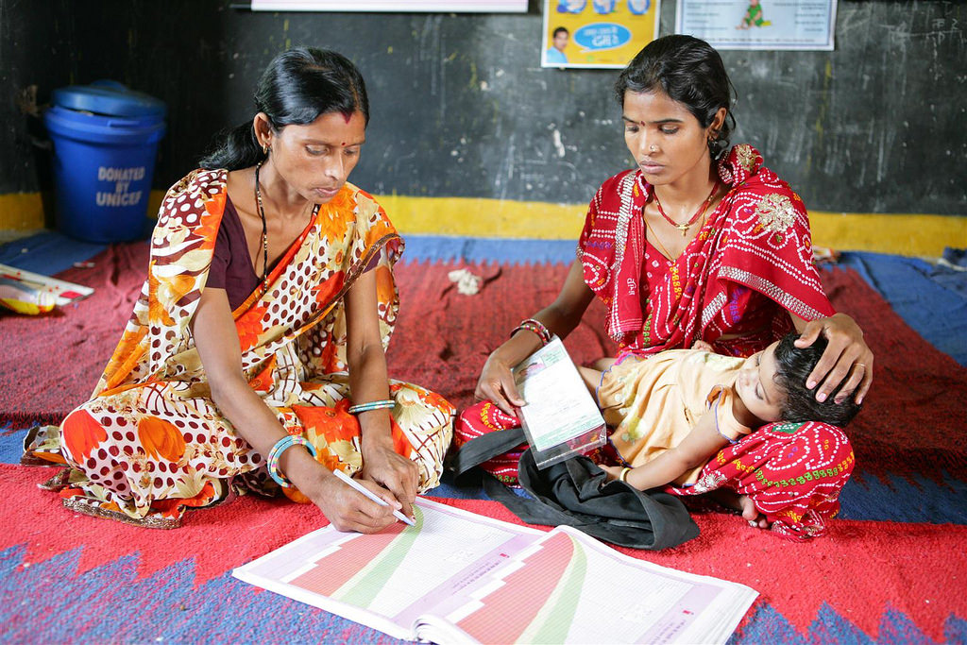
Figure 2. ASHA Holding a MHM Meeting

With girls’ reluctance for attending school during menstruation due to the lack of proper and private toilets, the Supreme Court issued a directive last 2011 that instructed all states to prioritize the construction of separate toilets for girls. The Indian government’s Total Sanitation Campaign (TSC) in 1999 was the first national program to ensure access to improved sanitation. In its guidelines, TSC has recognized the need for the program to incorporate hygiene promotion, provide women’s sanitary complexes (community facilities with latrines and bathing facilities), and construct girls’ toilets at schools. The main achievements of the program were 1) improved availability of sanitary pads, 2) increased awareness and greater demand for sanitary napkins, and 3) improved affordability of supply of pads to women. Consequently, TSC led to the 1) Menstrual Hygiene Scheme of the Ministry of Health and Family Welfare (MoHFW) for rural adolescent girls to enhance their MHM knowledge, improve their hygiene practices, provide subsidized sanitary absorbents, and raise awareness of MHM at school, 2) Ministry of Drinking Water and Sanitation (MoDWS)’s guidelines for sanitation in schools and its emphasis on MHM facilities and awareness raising, 3) MoDWS’ publication of the Menstrual Hygiene Management National Guidelines in 2015, and then to the 4) development of the Guidelines for Gender Issues in Sanitation last 2017.

B. Related Actors
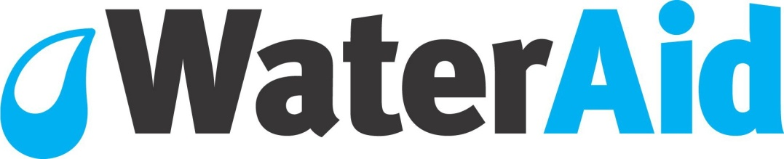
Figure 3. The Logo of WaterAid, an International Organization

MHM-related efforts were not initiated solely by the Indian government but also by numerous IOs, NGOs, and private enterprises. For instance, UNICEF India 1) supports the development of India’s national MHM guidelines and 2) provides leadership training for stakeholders, policymakers, and decision makers on MHM. WaterAid India provides 1) information about menstruation to women, girls, men, and boys to address taboos and 2) provides access to MHM products such as hygienic clothes and disposable sanitary pads. While numerous NGOs provide outsourced MHM education because some teachers find the topic embarrassing to discuss in a classroom, small-scaled private enterprises such as Jayashree Industries and Aakar Innovations develop low-cost pad manufacturing machines and sell them to NGOs that will manufacture and sell affordable pads and provide livelihood opportunities for women.

III. The Limitations of Menstrual Hygiene Management (MHM) in India
Despite the existence of MHM mechanisms in India, there are several limitations that hinder their successful implementation. First, government-level coordination is the key. However, as observed above, numerous Indian ministries have their own programs and projects when it comes to MHM. This leads to overlapping of goals and to eventual fragmentation. As MHM is an area that requires concerted action at the government, state, and district levels, systematic coordination among government ministries is important in order to ensure effective MHM programming, MHM monitoring, and MHM budget allocations. Moreover, government-level coordination will address: 1) the lack of dedicated operations and maintenance of funds, weak management and poor water availability, 2) limited access and affordability of sanitary napkins and washing facilities, and 3) the regular supply of the products through either mass production or government subsidy.
Second, the lack of human capital such as teachers and frontline workers serves as one of the obstacles for MHM in India. Indian adolescents both in the rural and urban slums remain uninformed or very little informed about MHM issues. Because family members often find the topic embarrassing or shameful to discuss, adolescent girls tend to rely on peers and mass media for information on menstruation. As there are many myths and misconception around menstruation, it is important to train teachers to provide psycho-social support to adolescent girls in schools and to provide regular hygiene promotion classes at schools.
Taking the previous point further, community awareness campaigns that target both men and women addressing taboos associated to menstruation are needed. However, it is most essential that all women, especially mothers in the family are educated and are counseled on the importance of the use of sanitary napkins, on MHM, and on menstrual hygiene. As such, the role of community health functionaries like ASHAs will be crucial in order to overcome the religious and cultural barriers behind menstruation. Some of the programs ASHAs can undertake are the following: 1) enhancing the awareness of menarche before the start of menstruation, 2) enhancing the perception of menstruation as a normal biological phenomenon, 3) increasing the awareness on the type of absorbents used and their disposal, and 4) reducing school absenteeism during menstruation.

IV. Conclusion
Menstrual Hygiene Management (MHM) is strongly correlated to the fact that women and girls in India are unable to afford the commercial product and that they do not have enough private spaces to look after themselves. While MHM-related mechanisms do exist in India, their effectiveness strongly depends on good government-coordination and increased societal awareness. As such, the Indian government should now work on two levels: (1) increase menstrual awareness and offer appropriate solutions for policymakers and the community and (2) implement a community-based participatory health education strategy that not only includes girls and women but also adolescent boys and men to bring behavioral and attitudinal changes. Consequently, the government can then discuss the supply and quality of napkins and the environmental impact that comes from these disposable pads, as it is estimated that 9,000 tons of waste will be produced annually from these pads. Lastly, the cooperation among IOs, NGOs, private enterprises, and the Indian government is highly encouraged in this effort to ensure sustainability of enhanced MHM in India.

References
Chanam, U., Ramdey, K. (n.d.). Breaking the Silence on Menstruation: Menstrual Hygiene
Management Training of Trainers in Saharanpur District, Uttar Pradesh, India. Retrieved from https://www.wsscc.org/2018/03/02/breaking-silence-menstruation-menstrual-hygiene-management-training-trainers-saharanpur-district-uttar-pradesh-india/
Dongre, A.R., Deshmukh, P.R., Garg, B.S. (2007). The Effect of Community-Based Health
Education Intervention on Management of Menstrual Hygiene among Rural Indian Adolescent Girls. World Health & Population, 1-8.
Garg, R., Goyal, S., Gupta, S. (2012). India Moves Towards Menstrual Hygiene: Subsidized
Sanitary Napkins for Rural Adolescent Girls – Issues and Challenges. Matern Child Health J, 16, 767-774.
Mahon, T., Fernandes, M. (2010). Menstrual Hygiene in South Asia: A Neglected Issue for WASH (Water, Sanitation and Hygiene) Programs. Gender & Development, 18(1), 99-113.
UN Children’s Fund & WaterAid. (2018). Menstrual Hygiene Management in Schools in
South Asia: India Country Snapshot. Retrieved from https://reliefweb.int/report/india/menstrual-hygiene-management-schools-south-asia-india-country-snapshot
UNICEF India. (2010). Accredited Social Health Activists (ASHA). Retrieved from
https://www.flickr.com/photos/152363980@N03/34364002840
UNICEF. (2014). WASH in Schools Empowers Girls’ Education. Retrieved from
https://www.unicef.org/wash/schools/files/MHM_vConf_2014.pdf
WaterAid India. (n.d.). Water Aid. Retrieved from
https://www.wateraid.org/where-we-work/india
World Bank Group. (2018). Menstrual Hygiene Management Enables Women and Girls to
Reach Their Full Potential. Retrieved from https://www.worldbank.org/en/news/feature/2018/05/25/menstrual-hygiene-management
WSSCC. (2016). Menstrual Hygiene Day 2016 – WSSCC Infographics. Retrieved from
https://www.wsscc.org/resources-feed/menstrual-hygiene-day-2016-wsscc-infographics/
Van Eijik, A.M., Sivakami, M., Thakkar, M.B., et al. (2016). Menstrual Hygiene Management
among Adolescent Girls in India: A Systematic Review and Meta-analysis. BMJ Open, 6, 1-12.

Seoul National University, Graduate School of International Studies
https://www.unicef.org/wash/schools/files/MHM_vConf_2014.pdf
Garg, R., Goyal, S., Gupta, S. (2012). India Moves Towards Menstrual Hygiene: Subsidized Sanitary Napkins for Rural Adolescent Girls – Issues and Challenges. Matern Child Health J, 16, 771.
https://www.wsscc.org/resources-feed/menstrual-hygiene-day-2016-wsscc-infographics/
https://www.worldbank.org/en/news/feature/2018/05/25/menstrual-hygiene-management
Garg, R. et al. (2012). p.769.
https://www.flickr.com/photos/152363980@N03/34364002840
Mahon, T., Fernandes, M. (2010). Menstrual Hygiene in South Asia: A Neglected Issue for WASH (Water, Sanitation and Hygiene) Programs. Gender & Development, 18(1), 101.
https://www.wateraid.org/where-we-work/india
https://reliefweb.int/report/india/menstrual-hygiene-management-schools-south-asia-india-country-snapshot
Garg, R. et al. (2012). p.768.
Van Eijik, A.M., Sivakami, M., Thakkar, M.B., et al. (2016). Menstrual Hygiene Management among Adolescent Girls in India: A Systematic Review and Meta-analysis. BMJ Open, 6, 2.
Dongre, A.R., Deshmukh, P.R., Garg, B.S. (2007). The Effect of Community-Based Health Education Intervention on Management of Menstrual Hygiene among Rural Indian Adolescent Girls. World Health & Population, 7.
https://www.wsscc.org/2018/03/02/breaking-silence-menstruation-menstrual-hygiene-management-training-trainers-saharanpur-district-uttar-pradesh-india/

